Name: Son Minh Tran

Student ID: 1773429

Lab 2

1. Here his the Breadboard Circuit diagram for my last student ID number digit recognizer.

A close up of a map

Description generated with very high confidence

Since I want my circuit to recognize 9 so only need SW0 and SW3 to be on. So the logic will look like this. The whole proof for my design will be like this

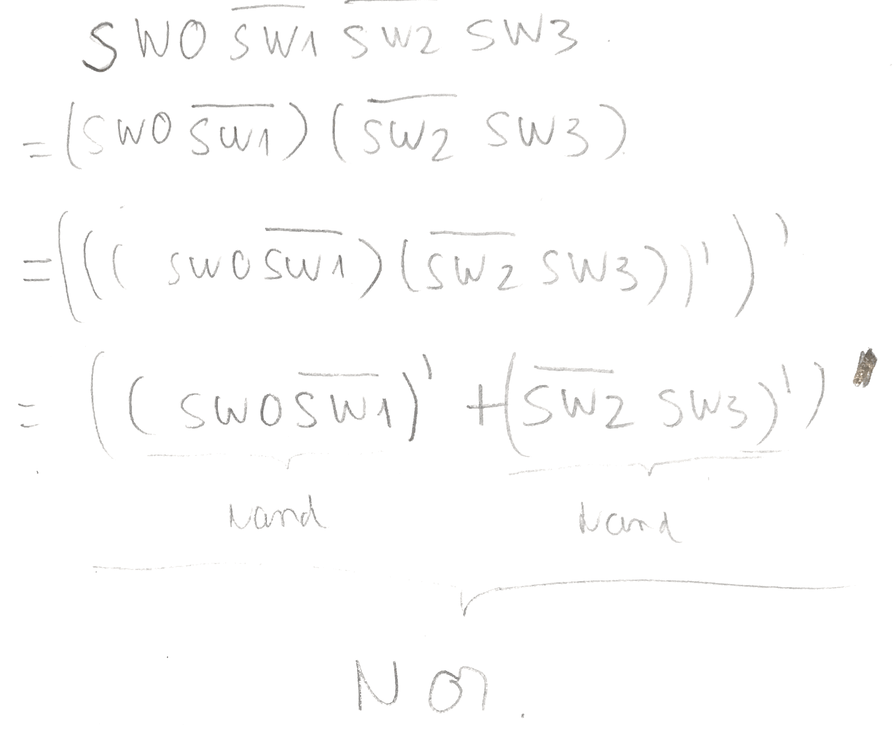

2)

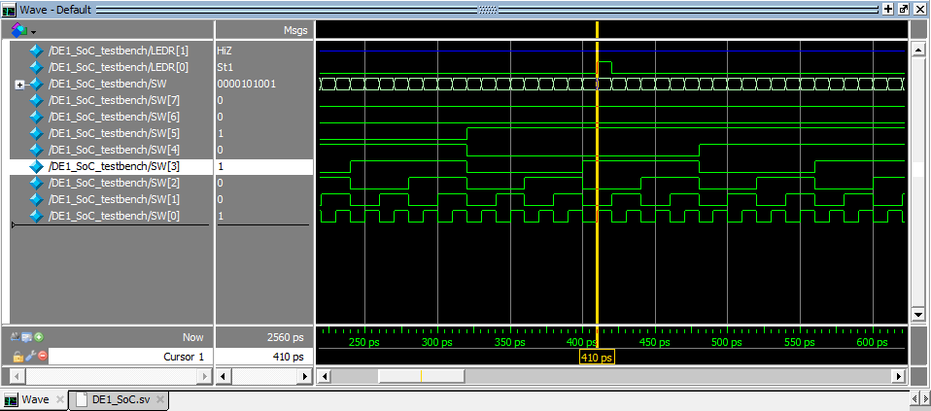

This is the simulation for my last digit circuits recognizer. The test bench will run all the possible case from 0 to 255 in decimal which is from 00000000 to 11111111. The Led output will only be set to 1 if SW[0] SW[3] SW[5] on, all other switch have to be off as the graph shown. This is because my last two digit are 2 and 9 which is encode as 0010 1001 in binary.

3. This lab took me 7 hours in total, including reading, planning, designing, coding, debugging, and testing.